3/9/2017
Jodi B. Boyko
SLM 503
Mrs. Boyko
The Best Children’s Literature

Table of Contents

- Letter to Students ………………………………………..…2
- Freedom to Read Statement……………………………..…..3
- Picture Books……………………………………………..…4
- Fiction Books……………………………………………....10
- Nonfiction Books…………………………………………..16
- Magazines………………………………………………….22
- Diversity…………………………………………………...24
- Notes/Sources……………………………………….……..25
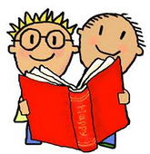

Dear Students,
I didn’t always define myself as a “Reader.” It had to start somewhere! The best place to start is always in the library with a good book!
Every book in this list is one that I have read, loved, and want to share with you. Each one is special—just like each of you! Curl up somewhere comfortable and dive into an imaginary world. Meet characters just like you, or just the opposite of you. Learn new things and look at the world a different way. Adventure to places you’ve never been! This library is yours to enjoy!
My greatest hope is that you will find that perfect book that turns you into a “Reader”!
Mrs. Boyko
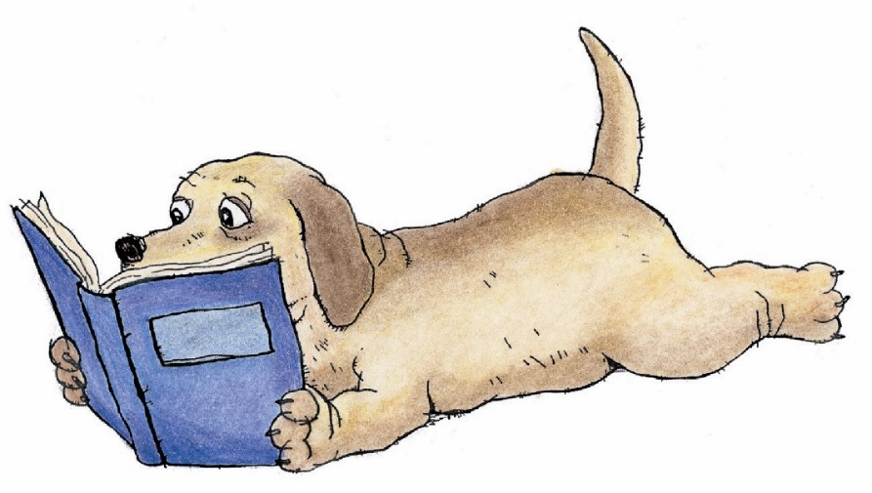

Freedom to Read
In this library you have the right to:
- Explore any book, free of judgment
- Stop reading a book for any reason
- Reread, skim, or select a new book at any time
- Read comfortably without interruption
- Ask any question, any time
- Suggest new books
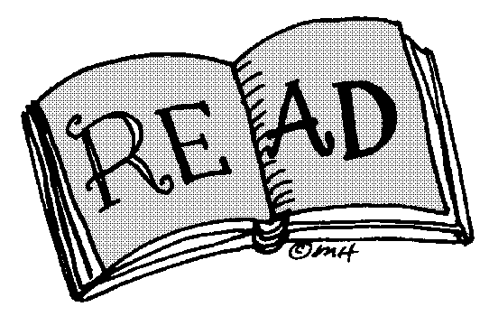

Picture Books
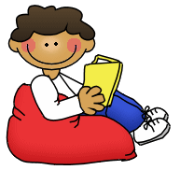

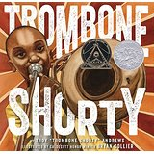

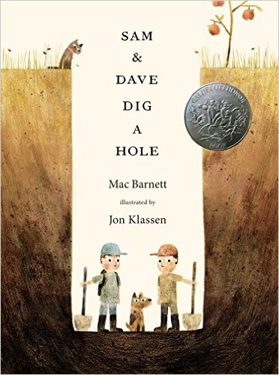

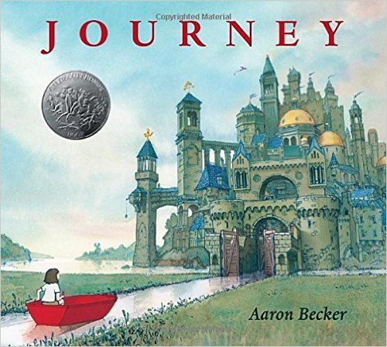

Andrew, Troy. Trombone Shorty. New York: Abrams, 2015.
How do musicians become famous? Troy lives in New Orleans—a lively city full of food, diversity, and music. All he wants is to be in a band like his brother. When Troy finds a beat up trombone twice his size, his dream is within his reach. Will the jazz festival make Troy’s dreams come true?

Barnett, Mac. Sam & Dave Dig a Hole. Somerville, MA: Candlewick, 2014.
One morning, Sam and Dave set out with their dog determined to find something “spectacular.” They dig up, down, this way and that way! After taking twists and turns throughout the day, will Sam and Dave ever discover "something spectacular?"

Becker, Aaron. Journey. Somerville, MA: Candlewick, 2013.
Adventure to worlds that need no words! Take an imaginary journey. See amazing new places, explore towering castles, rescue a beautiful purple bird, and maybe even make a few friends along the way!

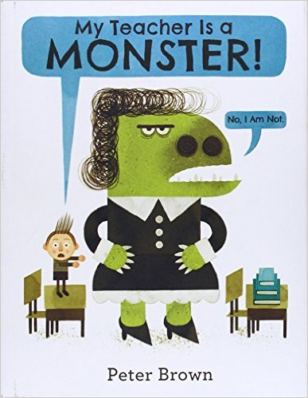

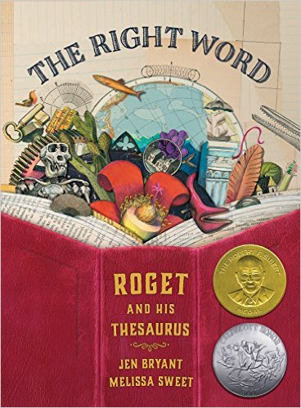

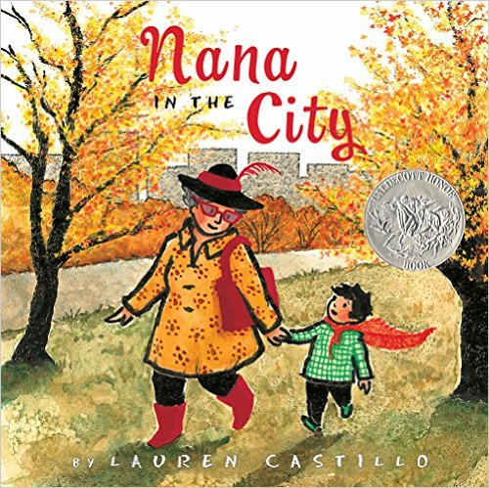

Brown, Peter. My Teacher Is a Monster! New York: Little Brown, 2014.
Stomp! Roar! Bobby’s teacher Ms. Kirby is a monster! He can’t wait to escape to his favorite place in the park. Bobby can’t believe who’s there—Ms. Kirby! He wonders if they can even talk to each other; but after an epic paper airplane flight, will Bobby still think Ms. Kirby is a monster?

Bryant, Jen. The Right Word: Roget and His Thesaurus. Grand Rapids, MI: Eerdmans, 2014.
Sometimes finding the right word is hard! As a child, Peter struggled to find the perfect word that fit how he felt. On his quest to find just the "right word" for any situation, Peter makes lists for everything. When lists, words, and meaning meet, Peter makes his own list of over 15,000 related words and publishes it to the world.

Castillo, Lauren. Nana in the City. New York: Houghton Mifflin, 2014.
What do you think cities are like? Are they busy? Loud? Are they filled with scary things? That’s no place for a Nana to live! Then Nana makes a special cape to make you brave and takes you to see the city. Maybe the city isn’t that bad. Maybe it is not only the perfect place for a Nana to live—maybe it will be the perfect place for a little boy to visit!

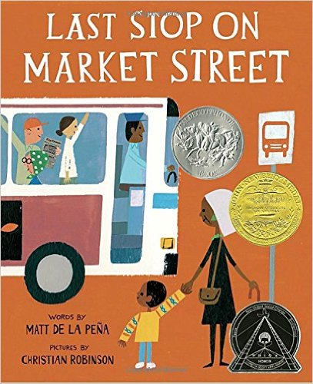

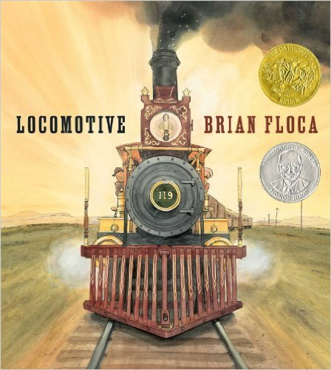

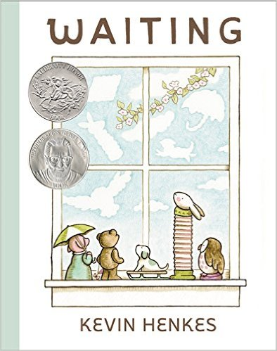

De La Peña, Matt. Last Stop on Market Street. New York: G.P. Putman’s Sons, 2015.
CJ doesn’t understand how his Nana finds beauty in everything. All he sees are the things around him are things her doesn’t have. The world looks so gray. He resents the weekly Sunday ride downtown with Nana. Then a special bus ride changes everything. After learning to see with his ears, will CJ find the beauty in the world around him?

Floca, Brian. Locomotive. New York: Atheneum, 2013.
Chug! Clank! Hiss! Choo-Choo! Take an amazing trip across the country on the Union Pacific Railroad! From Omaha to Sacramento, experience the sounds, smells, tastes, and scenery that made up the Wild West. Feel the vibration of the rails, the power of the steam engine as it twists and turns through the plains, across mountains, and down valleys. Take a journey you will never forget, and learn all about trains!

Henkes, Kevin. Waiting. New York: HarperCollins, 2015.
A pig, a bear, a puppy, a rabbit, and an owl are waiting. But what for? Each one is waiting for something different. It could be the moon, weather, or new friends. It could even be the unexpected! When a cat shows up, these friends discover that waiting can bring something wonderful!

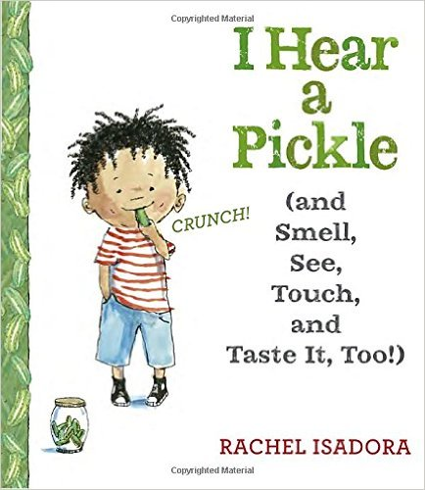

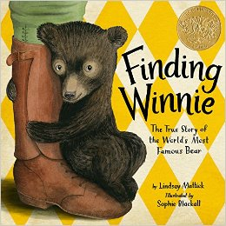

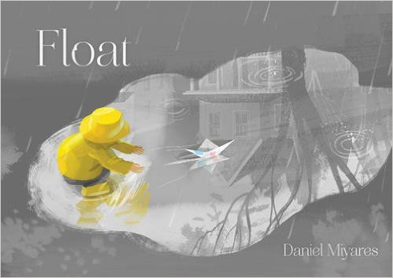

Isadora, Rachel. I Hear a Pickle (and Smell, See, Touch, and Taste It, Too!). New York: Nancy Paulson, 2016.
Do you know your senses? Let’s use them! Hear sounds that are soft, loud, and in between. Smell scents that are wonderful and a few that you may want to avoid, like your brother’s sneakers! See the world around you, and look for what is out of sight. Touch things that are soft, smooth, rough, and slimy. You can even taste new foods as well as foods you love! Explore your world with your senses!

Mattick, Lindsay. Finding Winnie. New York: Hatchett, 2015.
“Sometimes your heart makes up your mind for you.” There was something very special about Winnie—Harry could see it right away. Even the other soldiers in his unit could see it. Winnie trains with Harry and earns her own post in the army. From Canada to England, Harry and Winnie travel together. But when Harry has to leave Winnie behind in London, he wonders if she’ll make a new friend. Discover the true story of how the most famous stuffed bear in the world got a name!
Miyares, Daniel. Float. New York: Simon & Schuster, 2015.
Nothing is better than playing in the rain! Splash through puddles, feel the drops on your face, and sail down the street with your paper boat. The chase is on when your boat escapes! After a watery pursuit, will you rescue your boat? What will you do tomorrow when the sun comes back out? Discover how paper can become the greatest toy!

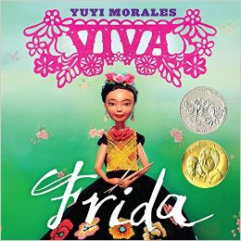

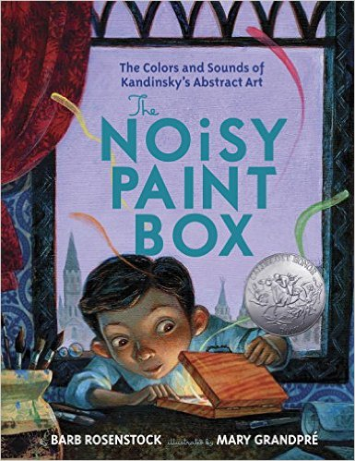

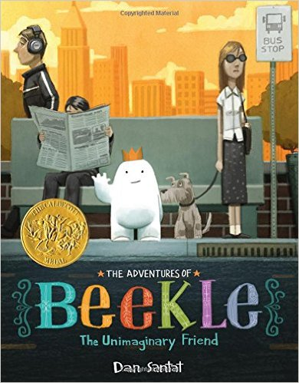

Morales, Yuyi. Viva Frida. New York: Roaring Book Press, 2014.
Sueno. Seinto. Y Entiendo. “I dream, I feel, and I understand.” Frida Kahlo was one of the best-known artists from Mexico. From colors, to textures, and all the wonder in between, learn Spanish and explore the world from Frida’s view. What makes you feel alive? Viva!

Rosenstock, Barb. The Noisy Paint Box. New York: Alfred A Knopf, 2014.
Can you hear colors? Vasya can! To him, colors are like music roaring from his paint box. He tries to be a proper Russian boy, but deep inside, he wants to paint music! But what do sounds look like? They aren’t like the houses and flowers he is told to paint. Will anyone ever understand Vasya’s paintings? Learn to listen to the colors and think outside the box!

Santat, Dan. The Adventures of Beekle: The Unimaginary Friend. New York: Little, Brown, 2014.
Beekle has been waiting a long time for his friend to imagine him and finally give him a name! When his patience wears out, he sets out to the real world to find her. It is full of dangers, strangers, and very little imagination. When he finds a playground full of children and their imaginary friends, he may finally be on the right track! But after waiting in a tree, Beekle starts to lose hope. Will his friend ever find him? Will he ever have his own name?

Fiction Books

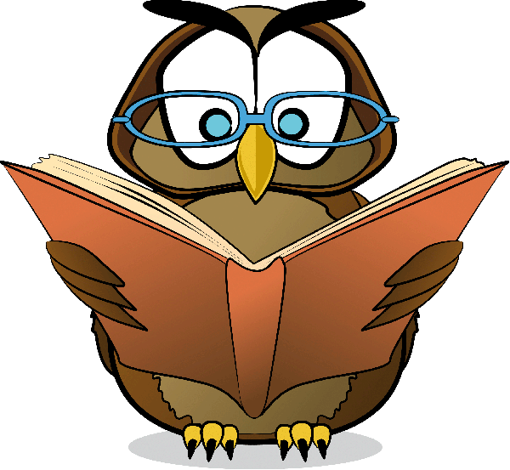

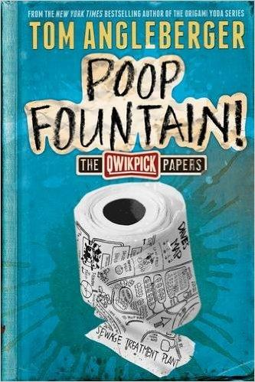

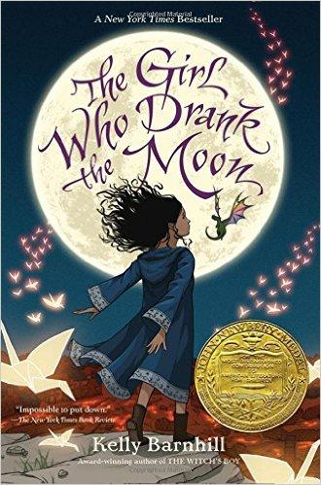

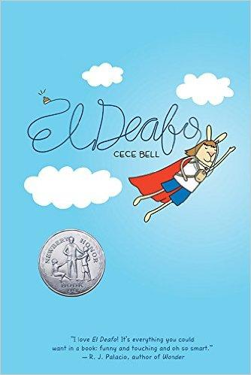

Angleberger, Tom. Poop Fountain: The Qwikpick Papers. New York: Abrams, 2014.
Lyle, Marilla, and Dave are the only members of the Qwikpick Adventure Society. They expect Christmas to be just another boring day when an adventure presents itself. The wastewater treatment plant is about to close, and with it will go the town "poop fountain!" No one has really seen it, but who wouldn't want to see a fountain of poop? The three friends set out on an adventure filled with cow pies, hill hopping, brambles, and yes—a poop fountain!

Barnhill, Kelly. The Girl Who Drank the Moon. Chapel Hill, NC: Algonquin, 2016.
There has never been another child like Luna. When she was just a baby, she was sacrificed to the witch, Xen. The good witch mistakenly fed Luna moonlight, filling her with magic. Xen, Glerk, the Swamp Monster and Fyrian, the Perfectly Tiny Dragon, raise the magical child. They are unaware of the trouble brewing in the town. When Luna's magic grows too dangerous, Xen must to lock it away. Is Luna the “witch” everyone should fear, or is there a power more evil in the town?

Bell, Cece. El Deafo. New York: Amulet, 2014.
When Cece gets sick at four years old, she loses her hearing. It’s so hard to figure out the world around her! Then she is given an amazing device—a Phonic Ear! All of a sudden, she has super powers! She can hear the teacher even when the teacher is out of the room! She is ‘El Deafo’! Will Cece’s super powers help her to make friends and fit in?

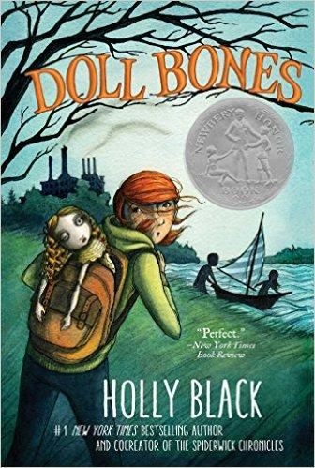

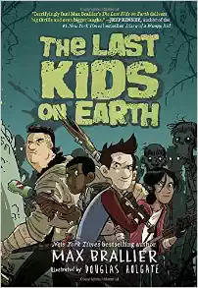

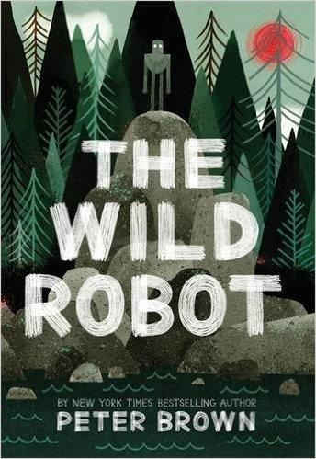

Black, Holly. Doll Bones. New York: Simon & Schuster, 2013.
Zach, Poppy, and Alice are masters at make-believe stories for their dolls and figures. But their lives change forever when one of the dolls, the Queen, starts haunting them. She sends them on a dangerous quest that will take them across the Ohio River. Can their friendship survive the journey, fear, and doubt that will follow? Or will the Queen haunt them forever?

Brallier, Max. The Last Kids on Earth. New York: Viking, 2015.
Foster kid Jack is one of the only survivors of the Zombie-Monster Apocalypse! Jack is determined to save his secret crush, June. In between battling a monster he names "Blarg" and fortifying his tree house base, Jack manages to find his best friend, Quint and former bully, Dirk. Together the three go on a mission to fight monsters and zombies and save June. But does June really need saving?

Brown, Peter. The Wild Robot. New York: Little, Brown, 2016.
When a cargo ship goes down in a hurricane, robot ROZZUM unit 7134 is the only "survivor." The robot attempts to adapt, from using camouflage to learning the language of the animals. She fears she’ll never fit in until she adopts a baby goose. Roz becomes a mother and learns that friendship makes up a family. Can Roz's animal friends save her when more robots come to recover her?

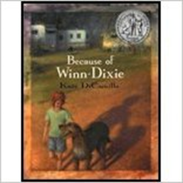

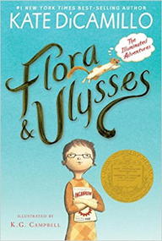

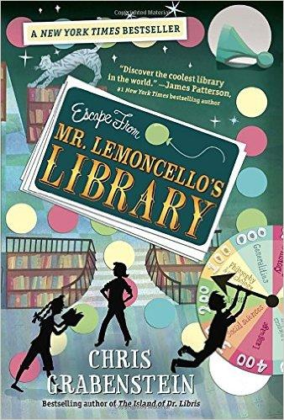

DiCamillo, Kate. Because of Winn-Dixie. Somerville, MA: Candlewick Press, 2000.
Opal is in the grocery store when she saves a dirty dog, Winn-Dixie. The dog changes her life. Opal is able to talk her father into telling her ten things about her missing mother. She makes friends with Franny Block, the librarian. She talks to Gloria Dump, the nearly blind woman that hangs bottles from trees. Even Otis, the ex-con that works in the pet store makes friends with Opal and Winn-Dixie. Will everyone in town change because of Winn-Dixie?

DiCamillo, Kate. Flora & Ulysses. Somerville, MA: Candlewick Press, 2013.
It all begins with a vacuum and one unfortunate squirrel. Flora Belle rescues the squirrel from the vacuum and is able to revive him. When Ulysses the squirrel awakes, he has super powers! He can fly and write poetry! He becomes Flora's best friend. But can the friends survive a battle with their arch-nemesis, Flora’s mother?

Grabenstein, Chris. Escape From Mr. Lemoncello’s Library. New York: Random House, 2013.
Kyle is awesome at games. He’s desperate to win a sneak peek night in the new library designed by Mr. Lemoncello, the best game designer ever! He can’t believe his luck when he’s picked. What starts as a cool sleepover turns into the ultimate game. Whomever can escape the library first wins! Every part of the library holds a clue. Can Kyle and his new friends work together to win this game?
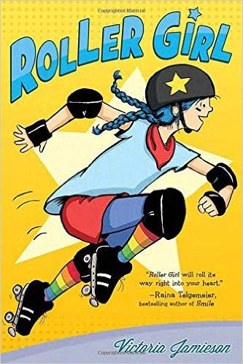

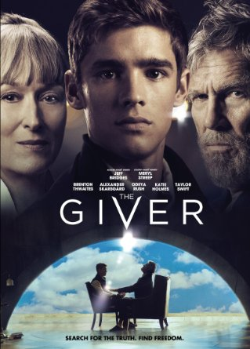

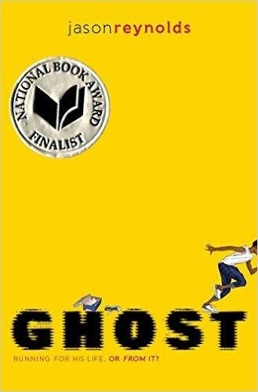
Jamieson, Victoria. Roller Girl. New York: Penguin, 2015.
Astrid has never seen someone as inspiring as roller derby star Rainbow Bite. She wants to be just like her—a Roller Girl! She’s determined that she and her best friend, Nicole, can do it. But when Nicole chooses ballet and a new friend over roller camp, Astrid thinks the summer can’t get any worse. Then at camp, she can barely stand on skates, let alone knock other girls over! Is this the worst summer ever? Or will Astrid find the strength within her to make new friends and become the roller girl she dreams of becoming?

Lowry, Lois. The Giver. Film. Directed by Phillip Noyce. Los Angeles: Walden Media, 2014.
Jonah has grown up in a place where everyone is perfectly equal. They know nothing of emotion, hardship, or color. On their eighteenth birthdays, children are given their professions. Jonah is given a unique job; he is to be The Receiver of Memories. The Giver unlocks Jonah's emotions and joy. He also gives him memories of great pain and suffering. When Jonah comes to realize how wrong his society is, will he be able to fight back?

Reynolds, Jason. Ghost. New York: Atheneum, 2016.
Castle is a troubled teenager with a lot of "red" in him. He doesn't seek out altercations, but they always seem to find him! Without thinking, he challenges a track star to a sprint and earns the attention of a former Olympian and track coach. For once, Castle, or "Ghost" as he asks to be called, may have everything finally going his way. But when one bad choice leads to another, will Castle ever be able to stop running from his past and just enjoy running?
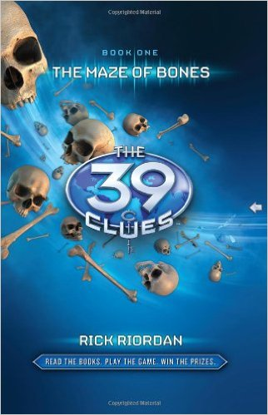
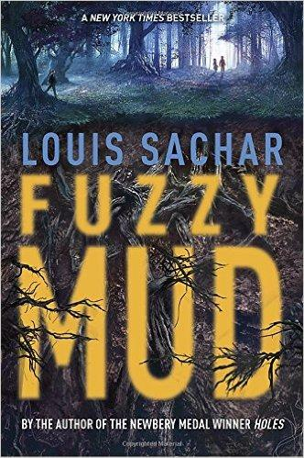
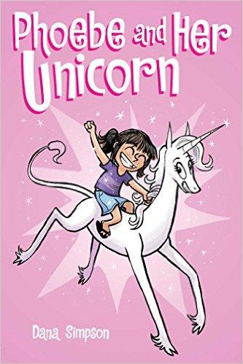
Riordan, Rick. The 39 Clues: The Maze of Bones. New York: Scholastic, 2008.
At the funeral of their grandmother, Amy and Dan Cahill are given a choice. They may either accept one million dollars or race other family members to uncover 39 clues. The clues lead to a secret that will make the winner most powerful person on the planet! The children go on the most dangerous scavenger hunt of their lives. Can Amy and Dan solve the clues?

Sachar, Louis. Fuzzy Mud. New York: Delacorte, 2015.
Heath Cliff, PA is home to Woodridge Academy—and SunRay Farm. The top secret facility is producing Biolene, a substance they hope will replace gasoline in cars. At Woodridge, Tamaya and Marshall have been dealing with the school bully, Chad. Trying to avoid a fight with Chad, the two cut through forbidden woods after school. They encounter "fuzzy" mud and use it to fend off Chad. This sets off an outbreak that spreads through the town. Tamaya and Marshall work to save Chad and themselves. Will the fuzzy mud mean the end of all their lives?

Simpson, Dana. Phoebe and Her Unicorn. Kansas City, MO: Andrews McMeel, 2014.
Phoebe is out skipping rocks when she accidentally hits a unicorn! Marigold Heavenly Nostrils is freed from staring at her glorious reflection and grants Phoebe one wish. Phoebe wishes that Marigold was her best friend; and thus, a friendship is born! Marigold is not only magical (her favorite spell is the "Shield of Boringness"), she also stands up for Phoebe. Together the two tackle the ups and downs of friendship!

Nonfiction Books

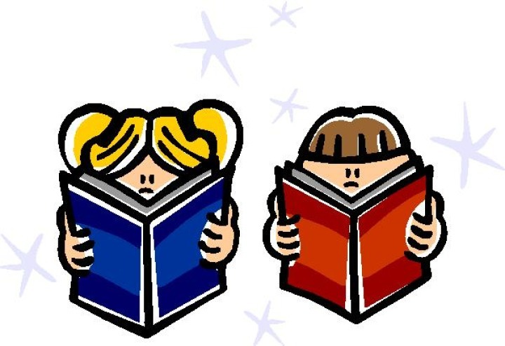

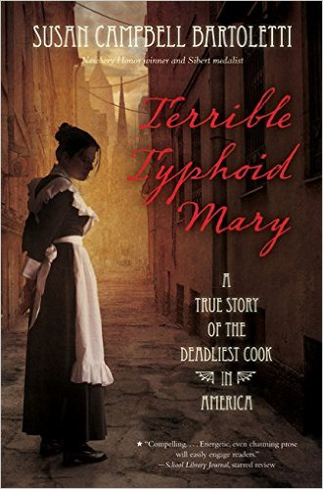

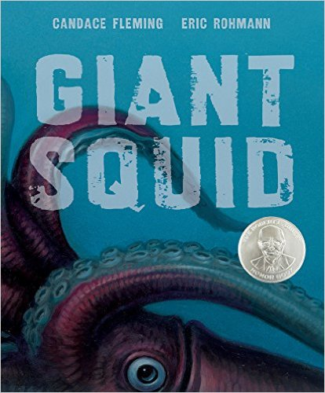

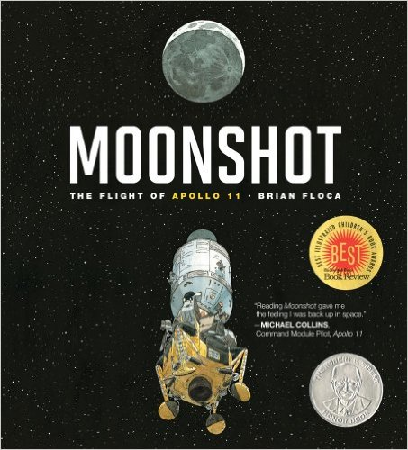

Bartoletti, Susan Campbell. Terrible Typhoid Mary. New York: Houghton Mifflin Harcourt, 2015.

If someone is sick, wouldn’t they know? Mary is perfectly healthy and works as a cook. After people get sick at every house she works at, doctors think Mary is the one that is making everyone sick. Mary doesn’t believe she’s carrying germs if she’s not sick. Who’s right, Mary or the doctors?

Fleming, Candace. Giant Squid. New York: Roaring Brook, 2016.

Dive into the ocean on a mission to find the giant squid. Just how big is it? What does it look like? What does eat? Does it really have a beak? Glide through the darkness of the deep sea and discover a giant squid—if you dare!

Floca, Brian. Moonshot. New York: Atheneum, 2009.

How do we get to the moon? Board a Saturn V rocket and blast off into space! Feel weightless as you float inside the capsule. Be the first person to set foot on the moon! Next, make the journey back home and splash back down into the ocean. Will you make it back to Earth?

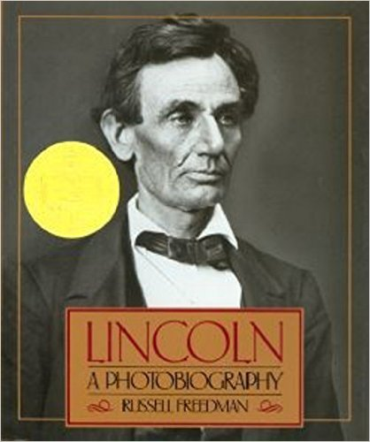

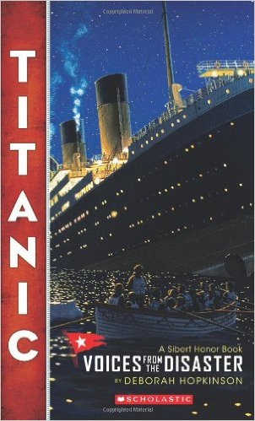

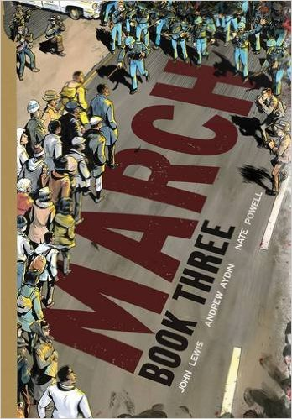

Freedman, Russell. Lincoln: A Photobiography. New York: Scholastic, 1987.

Meet the sixteenth President of the United States! Follow Abraham as a young boy growing up in Indiana and Illinois. Watch him teach himself to become a lawyer. Discover how he becomes President. Experience the hardship of the Civil War. How will Lincoln unite the country? Rare pictures provide a window through time!

Hopkinson, Deborah. Titanic: Voices from the Disaster. New York: Scholastic Press, 2012.

Board the Titanic and follow the ship from her first days at sea to her tragic sinking in the Atlantic. Read letters and see rare pictures taken by passengers. Meet the crew and explore the ship. When the worst catastrophe happens, draw your own conclusions—what really happened that night and why did the Titanic sink?

Lewis, Aydin, and Nate Powell. March: Book Three. Marietta, GA: Top Shelf, 2016.

John Lewis wants one thing—for African Americans to be treated equally. He's willing to stand up for his beliefs with the Freedom Democratic Party. African Americans everywhere are being denied voting rights. They’re suffering beatings and violence. Can one person make a difference? Can John inspire others to stand up for what's right?

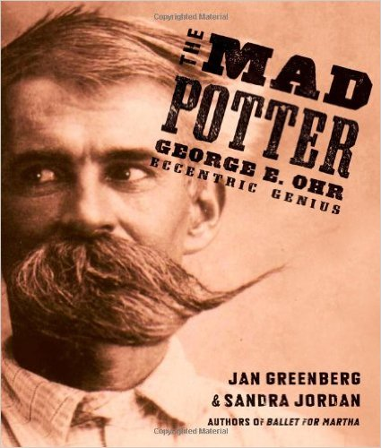

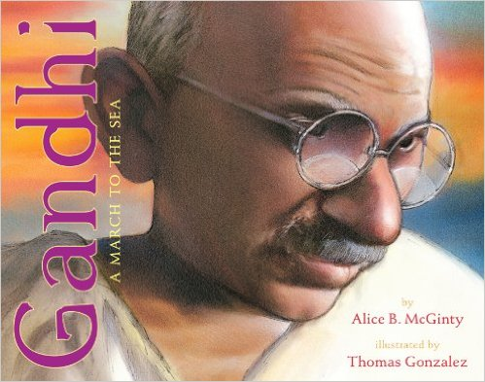

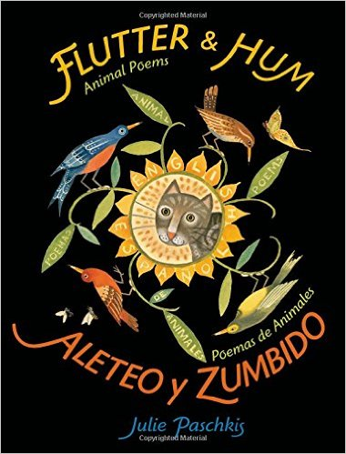

Greenberg,Jan and Sandra Jordan. The Mad Potter. New York: Roaring Brook, 2013.

George is the "bad boy" of his family. He grows up in the uncertain times after the Civil War. George is outgoing, a jokester, daring, and stubborn. Once he learns about making pottery, his career begins! During his lifetime, George makes hundreds of different pots. Then George gives demonstrations on making pottery. But will anyone ever buy George’s crazy looking pots?

McGinty, Alice B. Gandhi: A March to the Sea. Las Vegas, NV: Amazon, 2013.

Gandhi thinks that the people of India should be able to take salt from the sea to sell and to make their own clothes. He decides to protest peacefully for these rights. He walks twenty-three miles from his home to the seacoast. Along the way, Gandhi shares his message of freedom with the Indian people. Will the people of India come together to demand their rights?

Paschkis, Julie. Flutter & Hum. New York: Henry Holt, 2015.

What do animals sound like? How do they move? Where do they hide? Explore the world around you in both English and Spanish as you fly with birds, dive with whales, run with deer, and slither with snakes!

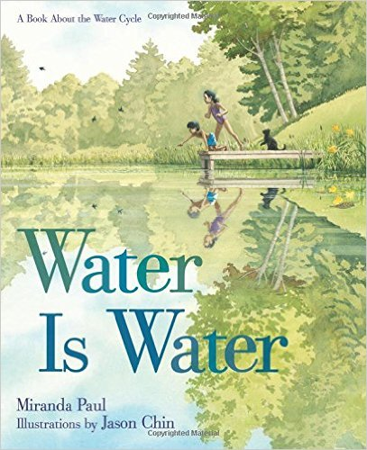

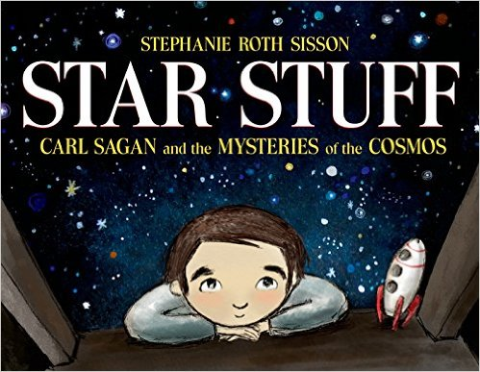

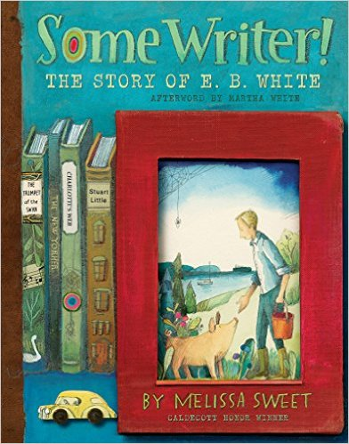

Paul, Miranda. Water is Water. New York: Roaring Brook, 2015.

How can water change? Follow water through all of its different forms: steam, clouds, mist, fog, rain, snow, and ice. See how water sinks into the ground, feeding trees, growing apples, and becoming part of the cider we drink. Learn all about the water cycle!

Sisson, Stephanie Roth. Star Stuff. New York: Roaring Brook, 2014.

Carl loves outer space. He wants to learn everything about it he can! Carl becomes a scientist so he can work with rockets and satellites. The more he learns, the more he wants to teach everyone about space! What will Carl teach you?

Sweet, Melissa. Some Writer! New York: Houghton Mifflin Harcourt, 2016.

When he is just seven years old, Andy White decides to become a writer. He writes poems, newspaper articles, and stories through school and college. He gets a job at a newspaper in New York writing articles, but at home he writes stories. Andy eventually writes his first book about a mouse named Stuart Little. Then he writes about a pig and a spider. Will children love Andy’s stories?

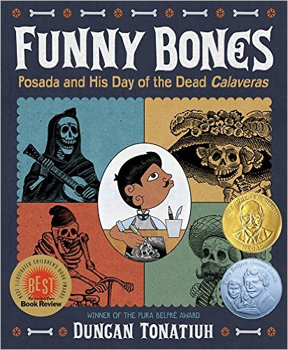

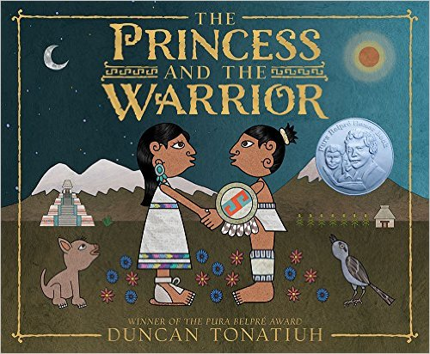

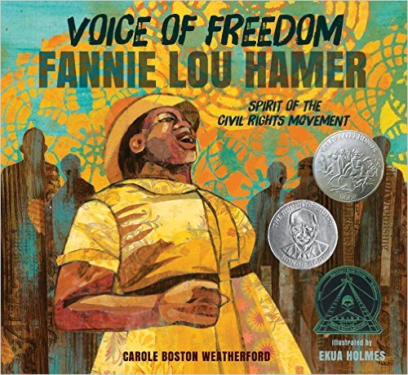

Tonatiuh, Duncan. Funny Bones. New York, Abrams, 2015.

José Posada is an artist in Mexico. He learns to make engravings and lithographs. Then José starts to draw cartoons! His cartoons have skeletons, or calaveras, dressed as regular people. He uses his cartoons to make fun of government. When the Day of the Dead, Dia de los Muertos, comes, José’s pictures of funny bones are perfect!

Tonatiuh, Duncan. The Princess and the Warrior. New York: Abrams, 2016.

Popoca is a warrior that falls in love with a princess, Izta. To prove he is worthy, Popoca goes to war to defeat Jaguar Claw. When Jaguar Claw knows he will lose, he tricks Izta into taking a sleeping potion. Will Popoca be able to wake his sleeping princess?

Weatherford, Carole. Voice of Freedom. Somerville, MA: Candlewick, 2015.

Fannie Lou Hamer lives in the south. Although the government says that black people are free, she and many black people in the south are not treated equally. Fannie decides to vote and stand up for her rights. Each time she is knocked down, beat, or jailed, she gets back up and tries again. Fannie is determined to be a voice of freedom.

Magazines

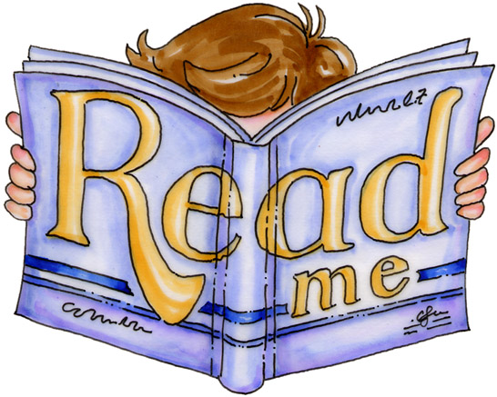

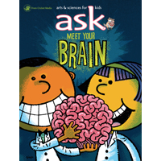 | Ask Magazine. https://shop.cricketmedia.com/ASK-Magazine-for-Kids.html  Art, science, and kids come together in this colorful magazine! Explore a new topic from every angle in each issue. ASK wants to answer your questions!
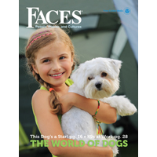 | Faces Magazine. https://shop.cricketmedia.com/FACES-Magazine-for-Kids  Travel around the world and learn about different people, cultures, and countries. Explore new places and try new things, from recipes to crafts!
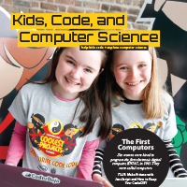 | Kids, Code, and Computer Science Magazine. https://KidsCodeCS.com  Want to do more than play video games? Learn how to make your own! Discover how computers work and jump into the world of technology!
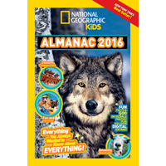 | National Geographic Kids Magazine. http://www.nationalgeographic.com/  If you’re interested in animals, insects, and nature, then this is the magazine for you! Full of facts, pictures, and games, this magazine will teach you about the world we live in!
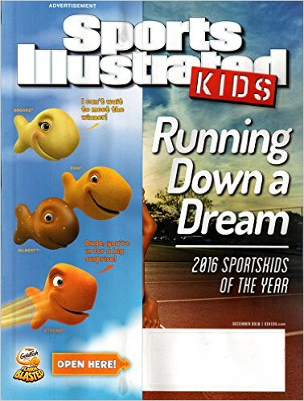 | Sports Illustrated Kids Magazine. https://www.sikids.com/  Want to get up and go? Read about your favorite sports, learn about new ones, and meet athletes from around the world. Get up and get active!
Diversity: Disabilities
As human beings, we all have one thing in common—we are all different. We have different colored skin, hair, and eyes. Sometimes we can see our differences, sometimes we can’t. These books are about people that are just as special as each of us. They are deaf, handicapped, or have a disability no one else may see. My hope is that you will find these characters and their stories as inspiring as I do!
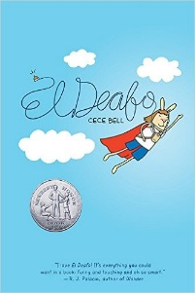 | Bell, Cece. El Deafo. New York: Amulet, 2014.  When Cece she loses her hearing, it is hard to figure out the world around her! Then she is given an amazing device—a Phonic Ear! All of a sudden, she has super powers! She can hear the teacher even when the teacher is out of the room!
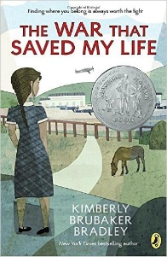 | Bradley, Kimberly. The War That Saved My Life. New York: Dial, 2015.  Ada has a bad foot and has never left her house. When she gets the opportunity to run away, she takes it! Adventure with Ada across the countryside of England during World War II.
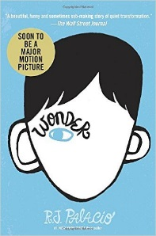 | Palacio, R.J. Wonder. New York: Knopf, 2012.  August doesn’t look like anyone else—he barely looks human. His face is disfigured. But August is just like you and I. Will he be able to convince his new classmates of that?
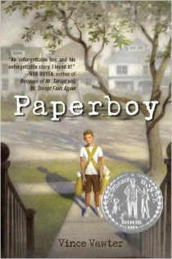 | Vawter, Vince. Paperboy. New York: Delacorte, 2013.  Victor may be a wonderful pitcher, but he can’t speak without stuttering! He takes over the newspaper route and his life changes. Victor meets a number of people that teach him that he’s more than a boy with a stutter!
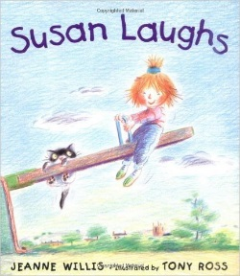 | Willis, Jeane. Susan Laughs. New York: Holt and Co, 1999.  Susan seems just like you or me. She sings, laughs, and cries. But there is one way that Susan is different! Read the book to find out!

Notes

Sources:

Book images all taken from www.amazon.com

Magazine images all taken from:

https://shop.cricketmedia.com/

https://www.amazon.com/Sports-Illustrated-Magazine-December-Sportskids/
  - Book searches conducted using Hoover Library’s Wilson’s Core Collection. All books listed are “Most Highly Selected”
  - Clip Art images taken from Bing “Creative Commons License”
  - Many book suggestions read due to high regard and recommendations by peers in McDaniel College SLM 503 Children’s Literature Spring 2017 class members. Thank you, ladies!
- Awards: This is a sampling of some of the best known and most highly regarded book awards given nationally and locally in Maryland!
  - Newbery
    - Awarded annually by “the Association for Library Service to Children (here forward abbreviated ALSC), a division of the American Library Association, to the author of the most distinguished contribution to American literature for children” (www.ala.org). All titles are published the previous year and selected by a committee of fifteen ALSC/ALA members. Commonly regarded one of the most distinguished awards a children’s author can receive.
      - http://www.ala.org/alsc/awardsgrants/bookmedia/newberymedal/newberymedal
  - Caldecott
    - Awarded annually by the ALSC to the illustrator/artist of the best American picture book published the previous year. Selection committee comprised of fifteen ALSC members. Commonly regarded as one of the most distinguished awards an children’s illustrator can receive.
      - http://www.ala.org/alsc/awardsgrants/bookmedia/caldecottmedal/caldecottmedal
  - Belpré
    - Awarded annually to “a Latino/Latina writer and illustrator whose work best portrays, affirms, and celebrates the Latino cultural experience in an outstanding work of literature for children and youth” (www.ala.org). Co-sponsored by both the ALSC and the National Association to Promote Library and Information Services to Latinos and the Spanish-Speaking.
      - http://www.ala.org/alsc/awardsgrants/bookmedia/belpremedal
  - Geisel
    - Awarded annually to the authors and illustrators of the best American “beginning reader” book. Selection committee includes six members of the ALSC.
      - http://www.ala.org/alsc/awardsgrants/bookmedia/geiselaward

  - Sibert
    - Awarded annually to “the most distinguished informational book published in English in the preceding year for its significant contribution to children’s literature” (www.ala.org). Selection committee of ALSC members.
      - http://www.ala.org/awardsgrants/robert-f-sibert-informational-book-medal
  - Coretta Scott King
    - Awarded annually to outstanding African-American authors and illustrators of children’s and young adult books that “demonstrate an appreciation of African American culture and universal human values” (www.ala.org). Selection committee is made up of members of the Ethnic & Multicultural Information Exchange Round Table (EMIERT) of the American Library Association.
      - http://www.ala.org/emiert/cskbookawards
  - Black Eyed Susan
    - Awarded yearly in the state of Maryland, this is a “children’s choice” award for fiction and nonfiction in grades 4-6 and 6-9 with separate categories for graphic novel format. All nominees are published in the previous three years, have positive professional journal reviews and are pre-approved by a committee before being presented to students. Schools and grades may participate according to guidelines and vote on nominees.
      - http://maslmd.org/about-bes/
  - Blue Crab
    - Selected once a year in the state of Maryland for beginning and transitional fiction, as well as nonfiction by a panel of Maryland Library Association members. The panel changes yearly.
      - http://www.mdlib.org/content.asp?contentid=195
  - ALA Notable
    - Selected once a year by the Association of Library Science for Children and automatically includes the Newbery, Caldecott, Belpré, Sibert, Geisel, and Batchelder Awards. Also includes additional notable books for younger readers, middle readers, and older readers. Selection committee includes ten members of the ALSC. Submissions are manually evaluated.
      - http://www.ala.org/alsc/awardsgrants/notalists/ncb
  - NCTE Orbis
    - Awarded once a year to one winner and five honorable mention nonfiction books published in the previous calendar year. Criteria includes: accuracy, organization, design, and style. Selection committee includes ten diverse members of NCTE including librarians, teachers, and administrators.
      - http://www.ncte.org/awards/orbispictus

